# Milestone 3

Table of Contents

Milestone 3 1

App video 1

Self and peer evaluation 2

Tinyiko’s Evaluation 3

Self-evaluation 3

Ronin St10437370 3

Keo ST10435348 3

Overall feedback 3

Ronin’s Evaluation 3

Keo’s Evaluations 4

# 

# App video

We took a video of our app because our code is perfect, but the app won’t run and we have tried everything to get it working but we failed, so we have sent the code on GitHub, but below is the app video.

[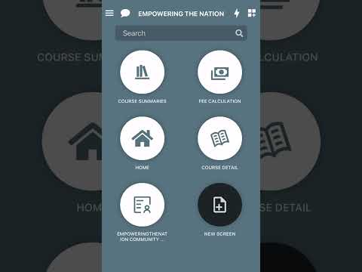](https://www.youtube.com/embed/g8Yj8E87PLo?feature=oembed)

Github link

[XHAW5112/webpage (2).zip at main · ST10437370Tyrese/XHAW5112 (github.com)](https://github.com/ST10437370Tyrese/XHAW5112/blob/main/webpage%20(2).zip)

# Self and peer evaluation

Group members

1.Ronin ST10437370

2.Tinyiko St10435344

3.Keo ST10435348

# Tinyiko’s Evaluation

# Self-evaluation

*During our work together, I would say I am pretty good with working with people, we didn’t have any arguments, we all got along and worked well together, I was the team leader in the beginning, and I would say I did a pretty good job at managing the boys and delegating tasks. And by doing so I also delegated tasks to myself which I managed to work on without any complaints. When the others encountered problems, I ensured that I give them a helping hand not once having to complain about them helping me. We all asked each other for help, and we pulled through for each other.

# Ronin St10437370

*Tyrese is a very good team member, he gives inputs and does the work delegated to him and ensures he goes the extra mile, it is such a great pleasure working alongside him. We encountered problems but not once did any of lose faith in the other, we kept focus on the main goal and stuck to our goals.

# Keo ST10435348

*Keo is a very good team member, he gives inputs and does the work delegated to him and ensures to go the extra mile, it is such a great pleasure working alongside him. Keo was mainly working on the mobile app, which is giving us problems, but he never gave up, he was persistent on getting it right and kept trying to get it working by trying other ways.

# Overall feedback

I believe that we all worked together very well, and I would jump to the opportunity to work with them again. We found common ground and always had our goal in mind, which is what kept us going, not once did we encounter any fights, or miscommunications about certain things, we all delegated tasks to ourselves based on what we are strong at and we have been working at it since day one, we helped each other where necessary without expecting anything in return. I do believe my group was the best and wouldn’t have traded them to any other group. We started off as strangers and as time went by, we all became friends. Which also makes the work even easier

# Ronin’s Evaluation

Self-Evaluation Reflective Report

ST10437370

Ronin Mauries

Introduction

I understand that WIL is an educational method that integrates academic study with hands-on, real-life experience in a professional environment. The aim of it is to connect theoretical understanding with practical implementation, offering students practical experience in their chosen field of study. This approach enables students to improve essential skills, acquire knowledge of the industry, and boost their chances of getting a job by incorporating real-world challenges into their academic studies. WIL is important as it nurtures professional development, enables students to use their learning effectively, and assists with a seamless integration into the workforce.

The skills I learned throughout the group sessions was communication skills. Learning each of our strengths and weaknesses along with accommodating for each other’s short comings. I also learned how to adapt the situation terms of the problem and solution for it. My brainstorming ability also improved throughout our group sessions.

Within our sessions, I had chances to be a group leader and secretary. Assigning simple tasks, communicating on the group, creating GitHub links for our team. I believe I have contributed to the team. We have not had any conflicts in our team. We all understand and compromise for our situations and work environments.

In conclusion, my WIL experience was both enriching and transformative. It allowed me to apply theoretical knowledge in a practical setting, enhancing my understanding of real-world challenges in my field. I gained invaluable hands-on experience, developed essential professional skills, and learned to adapt to dynamic work environments. This experience not only deepened my technical expertise but also improved my communication, teamwork, and problem-solving abilities. Overall, WIL provided me with a comprehensive perspective on my industry, better preparing me for future career opportunities.

# Keo’s Evaluations

Github link

<https://vscode.dev/profile/github/ae4354701f4b94709850b46f8e50f027>